

**Elserag**

A literacy platform for people with special needs

Graduation Project, Part- I (CS481)

Computer Science Department

Faculty of Computer and Information

Luxor University

Project Advisors

Dr. Hussein Alshafie

Dr. Hosny Ahmed Abbas

Eng. Ibrahim Elsayed

Submitted by

Mohamed AbdElrahman Elkhlawy

Amina Younis Mohammed

Manar Hussein Mohamed

Norhan Nageh Alabad

Omar Mohamed Elhassan

Sarah Nabil Kamel

Abstract

**First**, we want to know more about the people with special needs.

People with special needs encompass a diverse and heterogeneous group of individuals who face various physical, intellectual, sensory, or developmental challenges that may require additional support and accommodation. These challenges can result from conditions such as autism, Down syndrome, cerebral palsy, ADHD, dyslexia, visual or hearing impairments, and more. Special needs individuals often require tailored educational, social, and healthcare services to meet their unique requirements and maximize their potential for independent living and participation in society.

**Second**, we want to know more about the kinds of disabilities.

Disabilities encompass a broad spectrum of conditions and challenges that can affect an individual's physical, cognitive, sensory, or emotional functioning. These disabilities are often categorized into various types to better understand and address the specific needs of individuals. Some common types of disabilities include physical disabilities, which may involve mobility impairments, paralysis, or chronic health conditions. Cognitive disabilities encompass intellectual and developmental challenges such as autism, Down syndrome, and learning disabilities like dyslexia. Sensory disabilities include visual impairments, hearing impairments, and speech or communication disorders. Emotional and mental health disabilities cover conditions like depression, anxiety, and bipolar disorder.

**Blindness**, a sensory disability, creates unique challenges related to access to information, communication, mobility, and independence.

Focusing on blindness as the primary disability in our project represents a significant step towards fostering inclusivity and empowerment for individuals with visual impairments.

In our project, we aim to develop a literacy platform that caters specifically to the needs of blind individuals. This entails creating accessible digital content, leveraging assistive technologies, and adopting inclusive design principles to ensure that blind users can acquire and enhance their literacy skills effectively. By prioritizing blindness in our project, we contribute to the broader mission of making education and information accessible to all, regardless of their visual abilities.

Our project holds the potential to transform the lives of blind individuals, empowering them with the knowledge and skills necessary for personal growth, societal participation, and increased opportunities.

Contents List

Project Introduction………………………………………………..

**Chapter 1: Product Description**…………………………………

1. Client Description…………………………………………..
   1. Services………………………………………………...
   2. Objectives……………………………………………..
2. User Requirements………………………………………….
3. Domain Requirements………………………………………
4. Non-Functional Requirements…………………………….
5. Non Requirements…………………………………………...
6. Audience and Goals………………………………………….
   1. Audience…………………………………………………
   2. Product Goals…………………………………………..

**Chapter 2: Software Process Model Description**………….....

1. Key Phases………………………………………………………...
2. Key Principles………………………………………………………...

**Chapter 3: Product Definition**…………………………………….

1. Context Diagram……………………………………………...
2. Persons………………………………………………………...
3. User Stories…………………………………………………..
4. High Level Use Cases………………………………………
5. Use Case Descriptions……………………………………..

**Chapter 4: User Experience Wireframes**………………………

1. UX Interfaces…………………………………………………

**Chapter 5: Project Organization**…………………………………

**Chapter 6: Testing Plan**……………………………………………

**Chapter 7: Feasibility Study**………………………………………

1. Risk Identification
2. Risk Prioritization
3. Risk Mitigation

**Chapter 8: Configuration and Version Control**……………….

1. Processes
2. Attributes

**Chapter 9: Tools**……………………………………………………

**Chapter 10: Architecture**………………………………………….

List Of Figures

Figure 1. Name……………………………………………………

Figure 2. Name……………………………………………………

Figure 3. Name……………………………………………………

Figure 4. Name……………………………………………………

Figure 5. Name……………………………………………………

Figure 6. Name……………………………………………………

Figure 7. Name……………………………………………………

Figure 8. Name……………………………………………………

Figure 9. Name……………………………………………………

Figure 10. Name………………………………………………….

Project Introduction

Problem:

In a world where information is a cornerstone of empowerment and progress, there exists a profound issue that warrants immediate attention. **Individuals with special needs**, including those with physical disabilities, cognitive impairments, or sensory challenges, often face significant barriers when it comes to accessing and benefiting from traditional literacy education. Existing educational materials and platforms are not always designed to cater to the diverse needs of this population. This lack of inclusivity and accessibility can limit their opportunities for personal growth, communication, and participation in society.

Proposed Solution:

In response to this pressing challenge, we propose a groundbreaking project that aims to bridge this accessibility gap. Our project focuses on creating a specialized literacy platform designed exclusively for individuals with special needs. We believe in a holistic approach, where inclusivity and accessibility are at the core of our solution. Here are the key components of our proposed solution:

1. Adaptive Learning Materials: Tailored content and materials that adapt to the unique learning requirements of each user, ensuring they receive the most relevant educational resources.
2. Customized Learning Paths: Individualized learning paths that allow users to progress at their own pace and based on their specific needs and abilities.
3. Accessibility Features: Robust accessibility features, such as screen readers, text-to-speech capabilities, and customizable font sizes, to ensure a user-friendly experience for individuals with various disabilities.
4. Interactive Learning Tools: Engaging and interactive tools that make learning enjoyable and effective, including audiovisual content, gamification elements, and tactile learning experiences.
5. Progress Tracking: Comprehensive progress tracking and feedback mechanisms to help users and their support networks monitor their achievements and adapt the learning journey accordingly.
6. Community Support: A supportive and inclusive community where users can connect, share experiences, and seek advice from peers facing similar challenges.
7. Professional Guidance: Access to expert educators and professionals who can provide personalized guidance and support, ensuring that each user reaches their full potential.
8. Multilingual Support: Ensuring that the platform accommodates multiple languages, making it accessible to a broader global audience.
9. Privacy and Data Security: Stringent data privacy and security measures to protect user information and build trust in the platform.

By incorporating these vital elements into our project, we aim to revolutionize the way individuals with special needs access and benefit from literacy education, breaking down barriers and empowering them to thrive and engage fully in education and society.

Target Beneficiary Group:

The target beneficiary group for the "Literacy Platform for People with Special Needs" project includes individuals with special needs, particularly those who face challenges related to physical disabilities, cognitive impairments, sensory impairments, or other conditions that affect their ability to access traditional literacy education. This group encompasses a wide range of individuals with diverse needs and backgrounds, and the project is specifically designed to cater to their unique requirements.

Sustainable Development Axes Related to the Project:

1. Quality Education (SDG 4): The project directly contributes to providing inclusive and quality education for individuals with special needs, fostering lifelong learning opportunities.
2. Reduced Inequalities (SDG 10): By addressing the educational inequalities faced by individuals with special needs, the project contributes to reducing inequalities and promoting equal access to education.
3. Industry, Innovation, and Infrastructure (SDG 9): The project involves innovation in creating adaptive learning materials and technology to enhance literacy education for individuals with special needs.
4. Empowerment and Inclusion (Cross-cutting Theme): Empowering individuals with special needs through literacy education leads to their inclusion in social, economic, and political processes.

Chapter 1

**PRODUCT DESCRIPTION**

Intro

The proposed literacy platform for individuals with special needs is a pioneering solution designed to address the unique challenges faced by this diverse group. Our platform leverages advanced technologies and inclusive design principles to offer a comprehensive and accessible educational experience. Key features include adaptive learning materials that cater to individual learning requirements, customized learning paths allowing users to progress at their own pace, and a range of accessibility features such as screen readers and text-to-speech capabilities. Interactive learning tools, progress tracking, and a supportive community enhance the user experience, promoting engagement and personal growth. The platform also provides access to professional guidance, multilingual support, and prioritizes privacy and data security. This innovative product aims to empower individuals with special needs, breaking down barriers to literacy education and fostering a more inclusive and accessible learning environment.

Client Description

Our envisioned client base encompasses educational institutions, special needs organizations, and individuals dedicated to improving the educational experiences of those with special needs. These clients share a commitment to inclusivity and seek innovative solutions to address the educational challenges faced by individuals with diverse abilities.

Services

1. **Platform Integration**: Tailoring the literacy platform to seamlessly integrate with existing educational frameworks, ensuring a smooth adoption process for educational institutions.
2. **Training Programs**: Offering comprehensive training programs for educators, support staff, and administrators to maximize the platform's effectiveness in catering to the unique needs of individuals with special needs.
3. **Customization Services**: Providing customizable features and content to meet the specific requirements of different educational settings and individual learners.
4. **Technical Support**: Ensuring ongoing technical support to address any issues and optimize the user experience for both educators and learners.

Objectives

1. **Inclusive Education**: Facilitate an inclusive education environment by providing a platform that caters to the diverse needs of individuals with special needs, ensuring equal access to educational resources.
2. **Skill Enhancement**: Empower individuals with special needs to enhance their literacy skills, fostering personal growth and expanding their opportunities for future success.
3. **Community Building**: Foster a supportive community among educators, learners, and support networks to share experiences, best practices, and resources.
4. **Global Reach**: Extend the reach of the platform to a global audience by incorporating multilingual support, making it accessible to individuals worldwide.
5. **Data-Driven Improvement**: Utilize data analytics to track user progress, gather insights, and continuously improve the platform's effectiveness in meeting the evolving needs of individuals with special needs.

By aligning our services with these objectives, our literacy platform aims to be a transformative tool in the hands of our clients, driving positive change in the landscape of special needs education.

User Requirements

1. **Accessibility:**

* The platform should be compatible with assistive technologies such as screen readers, voice command systems, and Braille displays.
* Adjustable text sizes, high contrast options, and customizable color schemes to accommodate various visual needs.

1. **User-Friendly Interface:**

* Intuitive navigation and layout designed for individuals with varying degrees of digital literacy.
* Simple and clear instructions with minimal reliance on visual cues.

1. **Adaptive Learning Materials:**

* Content should adapt to individual learning preferences, pace, and abilities.
* Varied formats of content, including audio, video, and tactile materials, to cater to different learning styles.

1. **Customized Learning Paths:**

* Ability for users to set personal learning goals and follow individualized learning paths.
* Options for adjusting difficulty levels and content based on the user's proficiency and progress.

1. **Interactive Learning Tools:**

* Engaging and interactive tools such as quizzes, games, and collaborative activities to enhance the learning experience.
* Options for tactile and auditory interactions to cater to diverse learning preferences.

1. **Progress Tracking:**

* Clear and comprehensive progress tracking tools for both learners and educators.
* Regular feedback and performance analytics to monitor achievements and identify areas for improvement.

1. **Community Support:**

* A user-friendly forum or community space for users to connect, share experiences, and seek advice from peers and educators.
* Moderation and support features to ensure a positive and inclusive community atmosphere.

1. **Professional Guidance:**

* Access to qualified educators and specialists for personalized guidance and assistance.
* Virtual classrooms or one-on-one sessions to address specific learning needs.

1. **Multilingual Support:**

* Support for multiple languages to cater to a diverse user base.
* Easily switchable language preferences for both content and interface.

1. **Privacy and Data Security:**

* Robust data privacy measures to protect user information.
* Transparent policies regarding data usage and sharing, ensuring user trust and compliance with privacy regulations.

1. **Compatibility:**

* Cross-platform compatibility, enabling access from various devices such as computers, tablets, and smartphones.
* Compatibility with different operating systems and browsers to ensure a seamless experience.

By incorporating these **user requirements**, the literacy platform aims to create an inclusive and accessible learning environment for individuals with special needs, fostering a positive and enriching educational experience.

Domain Requirements

1. **Compliance with Educational Standards:**

* Adherence to educational standards and guidelines to ensure compatibility with existing curricula and educational frameworks.

1. **Scalability:**

* The platform should be scalable to accommodate a growing user base and evolving educational needs.

1. **Integration Capabilities:**

* Compatibility with learning management systems (LMS) and other educational technologies for seamless integration into existing educational environments.

1. **Data Analytics and Reporting:**

* Robust data analytics tools to track user engagement, performance, and learning outcomes.
* Reporting features to generate insights for educators, administrators, and policymakers.

1. **Security Measures:**

* Implementation of strong security protocols to safeguard user data and ensure compliance with data protection regulations.

1. **Continuous Improvement:**

* Mechanisms for continuous improvement based on user feedback, technological advancements, and educational research.

1. **Interoperability:**

* Interoperability with other assistive technologies and educational software to enhance the overall educational experience.

1. **Technical Support and Maintenance:**

* Provision of ongoing technical support to address issues promptly and ensure the platform's smooth operation.
* Regular maintenance and updates to address technological advancements and security concerns.

1. **Adaptive Learning Algorithms:**

* Implementation of adaptive learning algorithms that tailor content based on user performance and feedback.

1. **Community Engagement Features:**

* Tools to facilitate community engagement, collaboration, and resource-sharing among educators, learners, and support networks.

1. **User Training Programs:**

* Development of comprehensive training programs for educators, support staff, and administrators to effectively use and maximize the benefits of the platform.

1. **Multilingual Support Management:**

* Efficient management of multilingual support, including translation services and localization of content and interfaces.

1. **Regular Accessibility Audits:**

* Conduct regular accessibility audits to ensure that the platform remains in compliance with the latest accessibility standards.

1. **Legal and Ethical Compliance:**

* Adherence to legal and ethical standards related to accessibility, user data privacy, and inclusivity.

1. **Feedback Mechanisms:**

* Implementation of feedback mechanisms for users to provide input on the platform's usability, content, and features.

By addressing these **domain requirements**, the literacy platform aims to provide a robust and sustainable solution that aligns with educational standards, supports continuous improvement, and ensures a positive and inclusive learning environment for individuals with special needs.

Non-Functional Requirements

1. **Performance:**

* The platform should respond to user interactions within a maximum latency of 2 seconds to ensure a seamless and responsive user experience.

1. **Scalability:**

* The system must handle a concurrent user load of at least 10,000 users without significant degradation in performance.

1. **Reliability:**

* The platform should have an uptime of at least 99.9% to ensure continuous accessibility for users.

1. **Compatibility:**

* The platform must be compatible with the latest versions of popular web browsers (Chrome, Firefox, Safari) and mobile operating systems (iOS, Android).

1. **Security:**

* All user data must be encrypted during transmission and storage to ensure the highest level of security.
* The platform must undergo regular security audits and vulnerability assessments.

1. **Scalability:**

* The system should be designed to scale horizontally to accommodate an increase in users or data volume.

1. **Usability:**

* The platform must adhere to WCAG 2.1 accessibility standards, ensuring that it is usable by individuals with diverse abilities.

1. **Maintainability:**

* Codebase should follow modular and documented practices to facilitate easy maintenance and future updates.
* The system should support automated testing to ensure code integrity after updates.

1. **Interoperability:**

* The platform must support standard data exchange formats (e.g., LTI, SCORM) to enable interoperability with other educational systems.

1. **Data Backup and Recovery:**

* Regular automated backups of user data should be performed, and a reliable recovery mechanism must be in place in case of data loss.

1. **Technical Support:**

* Provide 24/7 technical support to address critical issues and ensure uninterrupted access for users.

1. **Multilingual Support:**

* The platform should support content and interfaces in multiple languages, with a seamless switch between languages for users.

1. **Documentation:**

* Comprehensive technical documentation for administrators, educators, and users should be available to facilitate ease of use and troubleshooting.

1. **Community Engagement:**

* Community engagement features should be designed to accommodate a large and diverse user community without compromising performance.

1. **Legal Compliance:**

* The platform must comply with international laws and regulations related to data privacy, accessibility, and educational standards.

By incorporating these **non-functional requirements**, the literacy platform aims to deliver a reliable, scalable, and secure solution that meets the highest standards of performance, usability, and accessibility for individuals with special needs.

Audience

1. **Educators and Instructors:**

* Teachers and educational professionals working with individuals with special needs.
* Inclusive education advocates seeking tools to enhance learning opportunities.

1. **Special Education Institutions:**

* Schools and organizations dedicated to special education and the well-being of individuals with diverse abilities.

1. **Individuals with Special Needs:**

* Learners with physical disabilities, cognitive impairments, or sensory challenges seeking accessible and tailored literacy education.

1. **Parents and Caregivers:**

* Guardians and family members of individuals with special needs, actively involved in supporting their educational journey.

1. **Special Education Administrators:**

* Administrators overseeing special education programs, looking for innovative solutions to improve educational outcomes.

1. **Policy Makers and Advocacy Groups:**

* Government officials, policymakers, and advocacy groups working towards creating inclusive educational policies and environments.

Goals

1. **Enhance Literacy Skills:**

* Provide a platform that effectively enhances the literacy skills of individuals with special needs, promoting independent learning and personal growth.

1. **Facilitate Inclusive Education:**

* Foster an inclusive education environment by offering tools and resources that cater to the diverse learning needs of individuals with special needs.

1. **Community Building:**

* Establish a supportive online community where educators, learners, parents, and advocates can connect, share resources, and provide mutual support.

1. **Empower Educators:**

* Empower educators with training programs, professional guidance, and resources to effectively use the platform and support learners.

1. **Global Reach:**

* Ensure the platform's accessibility and multilingual support, reaching a global audience and breaking down geographical barriers to education.

1. **Data-Driven Insights:**

* Provide data analytics and reporting features to offer insights into user progress, enabling educators and administrators to make informed decisions.

1. **Advocate for Inclusivity:**

* Collaborate with advocacy groups and policymakers to promote the importance of inclusive education and accessibility in the broader educational landscape.

1. **Continuous Improvement:**

* Continuously gather user feedback and leverage technological advancements to improve the platform's effectiveness and user experience.

1. **Educational Equity:**

* Contribute to the goal of achieving educational equity by ensuring that individuals with special needs have equal access to quality literacy education.

By aligning the platform's features and services with the needs and **goals** of this diverse **audience**, the project aims to make a substantial impact on the inclusivity and accessibility of literacy education for individuals with special needs.

Chapter 2

**SOFTWARE PROCESS MODEL DESCRIPTION**

The development of the literacy platform for individuals with special needs will follow an **iterative** and **incremental** model, combining elements of the **Agile** and **Spiral** process models. This hybrid approach is chosen to accommodate the evolving nature of user requirements, the need for continuous feedback, and the complexity of developing a solution that addresses diverse learning needs.

Key Phases

1. **Requirements Gathering:**

* Engage with educators, special education institutions, individuals with special needs, and other stakeholders to gather detailed and evolving requirements.
* Conduct usability studies to understand user preferences and challenges.

1. **Planning:**

* Define the project scope, objectives, and constraints.
* Develop a detailed project plan, including timelines, resource allocation, and risk management strategies.

1. **Design and Prototyping:**

* Create initial design prototypes based on gathered requirements.
* Seek feedback from the target audience, educators, and individuals with special needs to refine the design iteratively.

1. **Implementation and Testing:**

* Develop the core functionalities of the platform in incremental stages.
* Conduct continuous testing and debugging to ensure the reliability, security, and performance of each implemented feature.

1. **Release and User Feedback:**

* Release functional increments of the platform to a limited user group for beta testing.
* Gather user feedback to identify areas for improvement and iterate on the design and functionality.

1. **Iterative Development:**

* Based on user feedback and testing results, iterate on the design and implement additional features.
* Regularly release updates to address identified issues and enhance the platform.

1. **Training and Support:**

* Develop comprehensive training programs for educators and administrators.
* Provide ongoing technical support and address user queries and issues.

1. **Monitoring and Evaluation:**

* Implement data analytics to monitor user engagement, track progress, and gather insights into the platform's effectiveness.
* Regularly evaluate the platform's impact on literacy skills and educational outcomes.

Key Principles

1. **User-Centric Development:**

* Prioritize user feedback and involve end-users in the design and testing phases to ensure the platform aligns with their needs.

1. **Agile Development Practices:**

* Embrace agile principles such as iterative development, collaboration, and adaptability to respond to changing requirements and user expectations.

1. **Continuous Improvement:**

* Regularly assess the effectiveness of the platform and implement updates to address emerging needs, technological advancements, and educational research.

1. **Accessibility Compliance:**

* Adhere to accessibility standards throughout the development process, ensuring that the platform remains inclusive and usable for individuals with diverse abilities.

1. **Security Integration:**

* Integrate security measures at every stage of development to safeguard user data and maintain the trust of educators, learners, and administrators.

1. **Stakeholder Collaboration:**

* Foster open communication and collaboration among stakeholders, including educators, individuals with special needs, special education institutions, and advocacy groups.

This **hybrid iterative and incremental model** aims to balance flexibility and structure, facilitating the creation of a responsive, inclusive, and effective literacy platform for individuals with special needs. Regular feedback loops and continuous improvement will be integral to the success of the development process.

Chapter 3

**PRODUCT DEFINITION**

Context Diagram

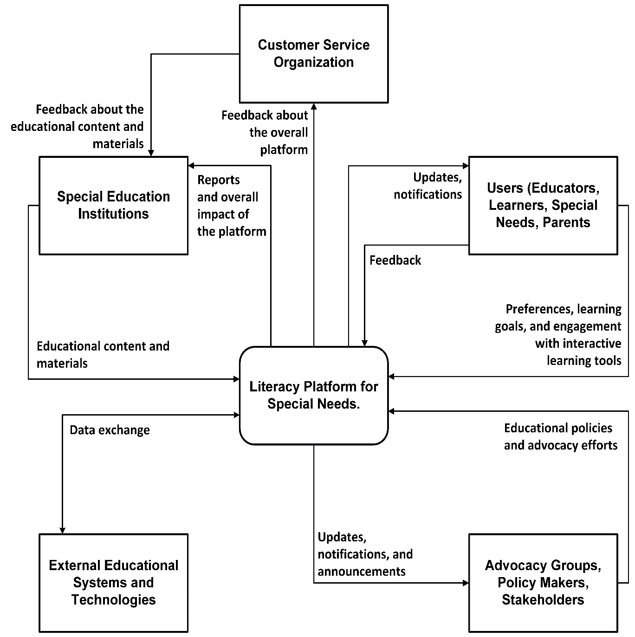

**Figure 1. Context Diagram**

System Architecture

Persons

Educators

* **Description**: Teachers, instructors, or educational professionals involved in teaching individuals with special needs.
* **Role**: They use the platform to access educational content, manage classes, and monitor the progress of learners.

Learners

* **Description**: Individuals with special needs seeking literacy education and skill development.
* **Role**: Actively engage with the platform to access adaptive learning materials, interactive tools, and personalized learning paths.

Caregivers

* **Description**: Guardians and family members of learners with special needs.
* **Role**: Support the educational journey of individuals with special needs, stay informed about their progress, and collaborate with educators.

Special Education Institutions

* **Description**: Schools, organizations, or institutions dedicated to special education.
* **Role**: Integrate the platform into their educational programs, contribute educational content, and monitor the progress of learners.

Policy Makers, Stakeholders

* **Description**: Entities involved in advocating for inclusive education, shaping policies, and having a stake in the success and impact of the literacy platform.
* **Role**: Provide input on inclusivity standards, educational policies, and advocate for the platform's effectiveness.

Community Members

* **Description**: Users participating in community engagement forums associated with the platform.
* **Role**: Engage in discussions, share experiences, provide feedback, and contribute to a supportive community environment.

Customer Service Organization

* **Description**: The system sends the whole users feedback to the customer service organization to process it.
* **Role**: Filter the feedbacks, then sends the feedbacks about the educational content and materials to the Special Educational Institutions, and handle any feedbacks about the user experience.

User Stories

High Level Use Cases

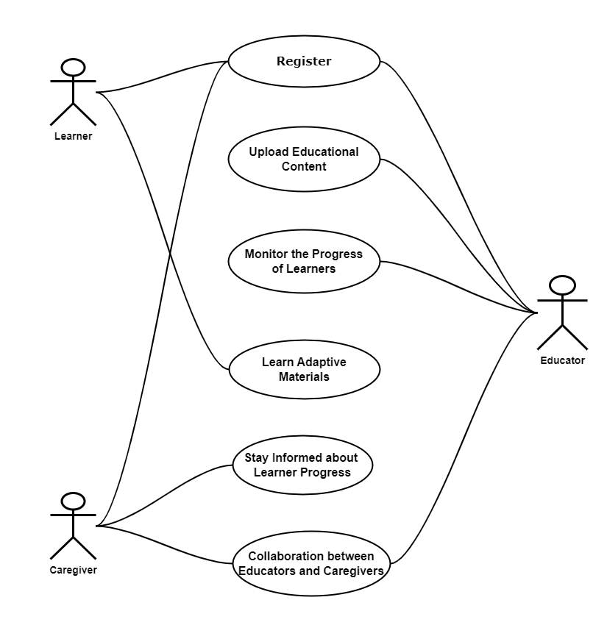

**Figure 2. Main Use Case Diagram**

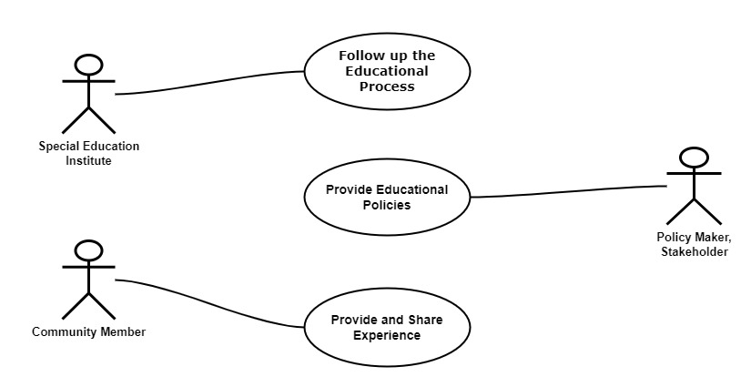

**Figure 3. Future Use Case Diagram**

Use Case Descriptions

Main Use Case Diagram

UC-1 🡺 Register

|  |  |
| --- | --- |
| **Description** | The "**Register**" use case in the mobile application refers to the process of creating a user account with biometric logging on the literacy platform for individuals with special needs. This feature enhances security and accessibility by utilizing biometric data for user identification and authentication. |
| **Actors** | **User**: Individuals with special needs, educators, caregivers, or any other user creating an account on the mobile application. |
| **Preconditions** | 1. The mobile application is installed and accessible on the user's device.  2. The device supports biometric authentication (e.g., fingerprint or facial recognition). |
| **Postconditions** | 1. A user account is successfully created and linked to the user's biometric data.  2. The user gains access to personalized learning materials and platform features. |
| **Trigger** | The user launches the mobile application for the first time or selects the "**Register**" option within the application. |

UC2 🡺 Upload Educational Content

|  |  |
| --- | --- |
| **Description** | The "**Upload Educational Content**" use case enables educators to contribute educational materials to the literacy platform for individuals with special needs. This feature empowers educators to share tailored content that caters to the diverse learning needs of the platform's users. |
| **Actors** | **Educator:** A teacher or educational professional responsible for creating and uploading educational content. |
| **Preconditions** | 1. The educator has a registered account on the literacy platform.  2. The educator is logged into the platform through the mobile application. |
| **Postconditions** | 1. The educational content is successfully uploaded to the platform.  2. The content becomes accessible to learners based on their individualized learning paths. |
| **Trigger** | The educator initiates the "**Upload Educational Content**" action from within the mobile application. |

UC3 🡺 Monitor the Progress of Learners

|  |  |
| --- | --- |
| **Description** | The "**Monitor the Progress of Learners**" use case enables educators to track and assess the academic progress of learners using the literacy platform for individuals with special needs. This feature provides valuable insights for educators to tailor their teaching approaches and offer additional support as needed. |
| **Actors** | **Educator:** A teacher or educational professional responsible for creating and uploading educational content. |
| **Preconditions** | 1. The educator has a registered account on the literacy platform.  2. The educator is logged into the platform through the mobile application.  3. Learners are actively engaged with the platform and have completed learning activities. |
| **Postconditions** | 1. The educator gains insights into the overall progress of learners.  2. Specific learner performance data, achievements, and challenges are accessible to the educator. |
| **Trigger** | The educator initiates the "**Monitor the Progress of Learners**" action from within the mobile application. |

UC4 🡺 Learn Adaptive Materials

|  |  |
| --- | --- |
| **Description** | The "**Learn Adaptive Materials**" use case enables learners to engage with adaptive learning materials on the literacy platform for individuals with special needs. This feature tailors educational content to the unique learning needs of each individual, promoting a personalized and effective learning experience. |
| **Actors** | **Learner:** Individuals with special needs actively engaging with the literacy platform for learning. |
| **Preconditions** | 1. The learner has a registered account on the literacy platform.  2. The learner is logged into the platform through the mobile application. |
| **Postconditions** | 1. The learner completes learning activities, quizzes, or interactive exercises.  2. The platform adapts subsequent materials based on the learner's performance and preferences. |
| **Trigger** | The learner initiates the "**Learn Adaptive Materials**" action by accessing the platform's learning resources. |

UC5 🡺 Stay Informed about Learner Progress

|  |  |
| --- | --- |
| **Description** | The "**Stay Informed about Learner Progress**" use case enables caregivers to monitor and stay informed about the academic progress of individuals with special needs using the literacy platform. This feature provides caregivers with insights into the learner's engagement, achievements, and areas for additional support. |
| **Actors** | **Caregiver:** Guardians or family members responsible for the well-being and educational support of learners with special needs. |
| **Preconditions** | 1. The caregiver has a registered account on the literacy platform.  2. The learner, for whom the caregiver is responsible, has an active account on the platform. |
| **Postconditions** | 1. The caregiver gains access to learner progress reports, achievements, and engagement metrics.  2. The caregiver stays informed about the learner's overall educational experience on the platform. |
| **Trigger** | The caregiver initiates the "**Stay Informed about Learner Progress**" action by accessing the learner's progress within the mobile application. |

UC6 🡺 Collaboration between Educators and Caregivers

|  |  |
| --- | --- |
| **Description** | The "**Collaboration between Educators and Caregivers**" use case facilitates communication and collaboration between educators and caregivers to ensure a coordinated approach to supporting the educational journey of learners with special needs on the literacy platform. |
| **Actors** | **1. Educator:** Teachers or educational professionals responsible for instructing learners.  **2. Caregiver:** Guardians or family members providing support and care for learners with special needs. |
| **Preconditions** | 1. Both the educator and caregiver have registered accounts on the literacy platform.  2. The learner, for whom the caregiver is responsible, is actively engaged on the platform. |
| **Postconditions** | 1. Educators and caregivers can exchange information, discuss learner progress, and collaborate on educational strategies.  2. Both educators and caregivers gain a comprehensive understanding of the learner's academic achievements, challenges, and personalized learning plan. |
| **Trigger** | Either the educator or the caregiver initiates the "**Collaboration between Educators and Caregivers**" action by accessing communication features within the mobile application. |

Future Use Case Diagram

UC7 🡺 Follow Up the Educational Process

|  |  |
| --- | --- |
| **Description** | The "**Follow Up the Educational Process**" use case allows Special Education Institutes to monitor and follow up on the educational process of learners within their programs using the literacy platform. This feature provides institutes with insights into overall progress, effectiveness of interventions, and areas for further support. |
| **Actors** | **Special Education Institute**: Educational institutions specializing in providing special education services. |
| **Preconditions** | 1. The special education institute has a registered account and administrative access on the literacy platform.  2. Learners associated with the institute are actively engaged in learning activities on the platform. |
| **Postconditions** | 1. The special education institute gains access to aggregated reports on learner progress, engagement, and overall performance.  2. The institute can identify trends, areas of improvement, and assess the impact of special education interventions. |
| **Trigger** | The special education institute initiates the "**Follow Up the Educational Process**" action by accessing administrative features within the mobile application. |

UC8 🡺 Provide Educational Policies

|  |  |
| --- | --- |
| **Description** | The "**Provide Educational Policies**" use case enables Policy Makers or Stakeholders to contribute educational policies, guidelines, and standards to the literacy platform for individuals with special needs. This feature ensures that the platform aligns with broader educational objectives and inclusivity standards. |
| **Actors** | **Policy Maker or Stakeholder:** Individuals involved in formulating educational policies, guidelines, or standards. |
| **Preconditions** | 1. The policy maker or stakeholder has a registered account and administrative access on the literacy platform.  2. The literacy platform actively seeks and encourages contributions from policy makers or stakeholders. |
| **Postconditions** | 1. Educational policies and guidelines are successfully submitted to the platform.  2. The provided policies are reviewed, then they become part of the platform's framework for inclusivity and education. |
| **Trigger** | The policy maker or stakeholder initiates the "**Provide Educational Policies**" action by accessing administrative features within the mobile application. |

UC9 🡺 Provide and Share Experience

|  |  |
| --- | --- |
| **Description** | The "**Provide and Share Experience**" use case empowers community members to actively contribute their experiences, insights, and feedback within the literacy platform for individuals with special needs. This feature fosters a supportive community environment and facilitates the exchange of valuable information. |
| **Actors** | **Community Members:** Users who actively participate in community engagement forums associated with the literacy platform. |
| **Preconditions** | 1. Community members have registered accounts on the literacy platform.  2. The platform actively encourages and provides features for community engagement and sharing experiences. |
| **Postconditions** | 1. Community members successfully share their experiences, insights, or feedback within the platform.  2. Shared content contributes to the collective knowledge and support network within the literacy platform community. |
| **Trigger** | The community member initiates the "**Provide and Share Experience**" action by accessing community engagement features within the mobile application. |

Sequence Diagram

Class Diagram

Chapter 4

**USER EXPERIENCE WIREFRAMES**

Chapter 5

**PROJECT ORGANIZATION**

Chapter 6

**TESTING PLAN**

Chapter 7

**FEASIBILITY STUDY**

Chapter 8

**CONFIGURATION AND VERSION CONTROL**

Chapter 9

**TOOLS**

Chapter 10

**ARCHITECTURE**

Conclusion